The 12th NISPAcee Annual Conference
Vilnius, Lithuania, May 13-15, 2004

USER CHARGES AND FEES IN ARMENIAN LOCAL GOVERNMENT SYSTEM

David Tumanyan1

Introduction
In order to examine changes in local reliance on taxes, fees and other revenues, it is necessary to define these terms and identify the types of revenue sources they include. This sounds like an easy task, but in different countries and local government systems, the distinction between taxes, user charges and other miscellaneous revenues can become blurred. Under the term of “User Charges and Fees” it is necessary to understand those payments, which are imposed for providing current services, or for the sale of products in connection with general government activities. User charges are paid for current consumption of goods and services and do not include fees for capital costs. As to the types and rates of the user charges and fees governments vary widely in their choices.

User charges and fees have a significant role in public services delivery issue. User charges allow governments to impose the cost of services on the citizens who demand those services. User fees, by assessing all or a portion of the cost of such services upon users, allow market forces to set an economically efficient level of services. User charges are an effective method of reducing consumption of scarce resources. For example, many community water systems have switched from unmetered water service funded from general revenues to metered services where customers are charged based upon consumption. User fees provide strong incentives to conserve water, reduce wastewater discharge by industrial users, and reduce the volume of solid waste that requires landfill disposal.

State and local governments set user charges and fees. One of the characteristics of democratic local governance is the right of local governments to impose user charges and fees. It gives possibility to local governments to take into account peculiarities of the certain community and to act flexible in price setting.

User charges and fees is one of the less studied theme in the field of local self-government in Armenia. Proceeding from this reality special attention will be paid to the following matters:
- Introduction of user charges and fees in the context of Armenian legislation.
- Local governments responsibilities related to services delivery and user charges and fees.
- Types of user charges and fees and practice of Armenian local governments to levy them.
- Peculiarities of user charges and fees in communities of different size.
- User charges and fees as local budget revenue.
- Best practices of user charges and fees usage and possibilities of their application in Armenia.

Chapter 1: Introduction of User Charges and Fees in the Context of Armenian Legislation
From 1922 to 1991, Armenia formed part of the Soviet Union and Armenian model of User Charges and Fees functioned as a component of higher centralized Soviet system. The types of user charges and fees were defined and their prices were leaved by the central government. After the independence Armenia began transition to the market economy and formation of the new system of public service delivery, one of which components is user charges and fees.

The new public administration system of Armenia has functioned since 1996. It is divided into two tiers: central government and local self-government. Public services delivery and price setting responsibilities are divided between them. There are two types of official prices that are relevant from the point of view of local public utility. One is the official price, stated by the central government and/or in public proceedings according to the rules of administrative procedures. The other is based on local legal regulation of local governments.

As in many transition countries prices of some user charges are approved and controlled by the national agency. Natural Monopolies Regulatory Commission (NMRC) leaves some kinds of user charges. It is so called independent state body, which has five members appointed by the President of Armenia upon presentation of the Prime Minister. NMRC defines prices on electricity, gas and drinking water delivered on pipeline network. Commission activity is regulated by the law on Energy and Water Code.

Local governments powers are divided into mandatory, voluntary and delegated by the State. Mandatory and delegated by the State powers must be implemented first of all. But local public services are based on the principals of mandatory and voluntary. The Law on Local Self-Government defines mandatory responsibilities of local governments in the field of public services as well as possibility to implement any activity, including public services deliveries, which are not against the laws.

Responsibilities of local governments in public service delivery are divided between community elders and the head of community. Community elders defines tariffs of public services delivery, approves the community budget, monitors budget implementation. So community elders is a community policy-making body in general and in the field of public services in particularly. The head of the community implements community policy with the help of his/her staff and community organizations.

It is necessary to mention that there are unclear statements in the legislation. The laws on Local Self-government and Budgetary system distinguish two groups of local fees as community budget revenue:
- Local fees, which are defined by the Law on Local Duties and Fees; and
- Other local fees, which are not clarified.
The Law on Local Duties and Fees prescribes procedures for the implementation of and requirements for nine local duties and three local fees. Under the law, community elders have the right to fix the rates within the defined range.
Local governments may charge the following fees:
• fee for local government services in preparing technical or financial documentation for the construction of new buildings or renovation of building facades;
• participation fee for auctions and tenders organized by the local self-government, for covering expenses;
• fee for government services in surveying land and other necessary activities in allocating, reclaiming or renting local government property.

Community Elders leaves the tariffs for the service delivery by the community according to the general statements of the Law on Local self-government. Official prices stated by communities in their local legal statutes in the following services:
- waste removal;
- drinking water for only own local water supply system, except Yerevan district communities;
- sewer delivered by municipal water works, except Yerevan district communities;
- local public transport, except Yerevan district communities;
- public heating, except Yerevan district communities;
- parents fees for kindergartens, vocational schools, etc.;
- maintaining services in public cemeteries, except Yerevan district communities.

Public Utilities have an important place in the system of public services because customers are all citizens. Some description of public utility reform is done bellow.

1.1 Electricity
Considerable progress has been made in reforming the energy sector since 1995 (accomplishments including: 24 hours supply; increased tariffs and reduced cross-subsidization; improved payment discipline and transparency of financial flows; diminished accumulation of quasi-fiscal debts; adoption of the Energy Law, and establishment of Energy Regulatory Commission (ERC)). On I January 1999 the increasing block tariff was eliminated in favor of a single price of 25 AMD per kw/h.

Despite this progress, however, Armenia's energy sector is still characterized by inefficient use patterns, significant losses and degraded infrastructure. Household's response to increased electricity tariff was in reduced electricity consumption records (drop on average 17 %) and increased consumption of such substitutes as wood and natural gas increased, with poor exhibiting this pattern more relative to the non-poor, since the burden of energy expenditures is larger for them (16% of monthly cash expenditures on electricity). 1999 tariff increase was accompanied by an expansion of the poverty family benefits system (to soften the impact of the tariff increase) and, in addition, a direct income transfer to a portion of poor households.
Recently the four electricity distribution networks were privatized. UK based “Midlend Resources” became the 80% owner of energy distribution network (with the 20% in the GoA hands).
The role of local governments is close to none. It raises some problems and it is necessary to increase their role in the energy system.

1.2 Water Sector
Despite a significant progress achieved in water resource management (WRM) reform, it -both municipal and irrigation water- is still in crisis (due to economic hardship, heavy dependence on energy imports, failures to cover maintenance costs, etc), characterized by:
- financial crisis, with 20-50% collections rates at 0.2% of GDP and billings-0.9% GDP;
- poor reliability and quality of supply;
- degraded infrastructure with the cost of investment need estimated at 1 billion US dollars;
- heavy burden on the state budget of water subsidies- reaching 2% of GDP, exceeding the annual planned revenues of the utility companies 2.9 times, and the factual ones- 11.9 times.
A lot has been achieved by the GoA on its way of reforming water sector by now, including:
- Study on Integrated Water Resources Management Planning (IWRMP, 1999);
- Separation of regulatory, standard setting and operational functions into independent roles with the adoption of a “Program for the reform of water management system” (2001);
- A plan for achieving financial sustainability of water sector- with the adoption of a “Reform Program to improve the financial sustainability of the companies responsible for the provision of drinking water supply/wastewater and irrigation/drainage services” (05/2001);
- A New Water Code (2002), and laws on Water User Federations, Condominiums and Management of Multi-apartment buildings;
- Formation of a Water Resource Management Board under the auspices of the Ministry of Nature Protection and a National Council on WRM, chaired by the Prime-Minister.
GoA WRM reform program includes: achieving an integrated approach to WRM; transfer of the operation of the main water operators on a commercial basis; wide adoption of participatory water management practices; financial reform - gradual removal of state budget subsidies by 2007; continued capital investments in the infrastructure (mainly with long-term loans on favorable terms) to ensure sustainable operation of the system; a wide scale program on the sustainable use of water resources, including a water preservation program, introduction of tradability of water rights and water markets.

State Committee of Water Resources (SCWR): took over the responsibilities for the financial and operational tasks related to provision of commercially-oriented water services (e.g. bulk water supply, sanitation, irrigation, drainage), gradually devolving responsibilities for service delivery to water user groups, applying integrated planning to maximize the use of the resources at the macro (national perspective) and micro (sectoral perspective) levels. In addition to the agencies described in the picture, many other government bodies play a part in WRM- with oftentimes overlapping functions. In the recent year setting of the water pricing responsibility was given to the NMRC.

The GoA has taken a moderate view on the issue: it sees privatization as a final solution at some point, perhaps in ten years time. It sees the transformation of “Irrigation” JSC, YWSC and AWSC into full commercial entities, to achieve cost-recovery at a minimum in the coming 3-5- years, with introducing management changes using management contracts, concessions, and so on. This is a positive sign - in line with the lessons learnt from the international experience.

1.3 Community Water Sector
Institutional responsibilities in this sector are as follows:
a) Yerevan Water and Sewerage Company (YWSC), currently operating under a management contracts with Italian “Acer & Company Armenian Utility S.C.AR.L“ with IDA funding.
b) Armenian Water and Sewerage Company (AWSC), GoA is currently working on transforming its 46 branches into legally independent entities, and seeking private sector participation for their (joint or separate). The feasibility study is already ongoing.
c) A third operator, “Nor Akunq” (“New Source”) has recently been established (as a model experimental project, with a funding form GTZ/KfW) in Armavir marz: a shareholding company owned by the GoA, cities and villages councils. It delivers water to directly to consumers.

Local governments are theoretically responsible for:
- Ensuring water supply in their communities- according to the Law on Local self-government.
- Provision of drinking water and wastewater services within their geographic boundaries. The internal water canals are their property. As of 1999 however, almost all of them have transferred their O&M to YWSC and AWSC (GoA decree NO. 149, 13/03/1999). This is supposed to hold until the branches of AWSC are separated out as legally independent entities.
- Defining retail prices for municipal water and wastewater. Currently however, this is not the case in the light of the contracts. AWSC and YWSC establish retail tariffs, but subject to approval by community elders. It is envisioned that this function will be transferred to condominiums, the role of which is supposed to strengthen significantly.
- Organizing water users groups, mobilizing condominiums. Currently however, this is also done mostly by AWSC and YWSC.
Recently the GoA gave a new impetus to the reforms, by initiating a few important measures.

The key problem, and also behind the contracts mentioned above, is more fundamental and multifaceted.
- While (a) the Law on local self-government stipulates that ensuring the supply for the population with drinking water is the responsibility of local self-government bodies, and (b) the key GoA Decrees (No 92 and 440) underline the role of communities, in the light of the fact of the transfer of O&M of inter-community water supply networks to water operators, now the latter (and not the local governments, as one would expect) are actively involved in mobilizing condominiums. Local governments are essentially left out of the picture: only when neither condominiums, nor other forms of management of multi-apartment buildings (licensed or entrusted management) is present in a given community, they, as specified by the Law on the Management of Multi-Apartment Buildings should temporarily take over their functions, until the latter are organized
- Condominiums (as well as licensed or entrusted management bodies of multi-apartment buildings) are in charge of collecting water user fees (and repair and maintenance of intra-building pipelines- see below), taking over the responsibility for managing the municipal water use within apartment buildings. And from here an important problem starts. While the contracts between water operators and households specify that the operator is responsible for ensuring the agreed on amount to the household, currently, they (as a result of the management transfer contract between with local self-government bodies), have taken over the O&M of the internal pipelines only up to the entry point into the building. The intra-building pipelines are, according to the Civil Code from 1999, under a shared ownership of the households. Thus, in case of a problem with intra-building pipelines, or when the water pressure is not enough and a motor is to be installed in a building, a household will face a problem, which is in legislative/regulatory flux. Water operators sign (or will sign) contracts with condominiums (or licensed or entrusted management). In fact there is a form of a contract developed between operators and condominiums, and those were signed in a number of communities. This process is proceeding with difficulties, however, because it was largely recognized that the contracts were deficient, as a result of (mainly, but not only) the problems described above: the contracts specify that the condominium is responsible for the maintenance of intra-building pipelines, while the financial and technical base for these are not clear. Again, no role is stipulated for the local government bodies.

The issue of the condominiums requires a special emphasis. Now they exist almost exclusively in Yerevan, and even those until very recently were not involved in water provision or wastewater services. Moreover, established by the law from 1996 after the give-away privatization of apartments to individual tenants and despite massive donor assistance, the experience with condominiums was not successful until now. Coverage of the privatized stock is estimated at around 40-45%, with only about 5% of the condominium associations being deemed to be able to undertake major investments. Many objective (like the inadequate legislative base) and subjective reasons are behind that. In any circumstance, the role of local governments should not be marginalized, and should be better defined- since they could provide the missing link in solving the existing problems. While the GoA has stated the goal of an increased involvement of and strengthened capacity for marz and community levels in formulating and implementation of WRM strategies in view of decentralization and the devolution of responsibilities, at the moment the local government bodies are left completely out of the picture, and do not have almost any say in the regulatory, O&M framework of water (with the exception of “Nor Akunq” scheme).

Along with a gradual approach to private sector participation in WRM, a gradual shift (within 8-10 years) to water-scheme based management is stated in the Program for Water Sector Reform through:
- increased involvement of and strengthened capacity for marz and community levels in formulating and implementation of WRM strategies in view of decentralization and the devolution of responsibilities;
- (a) separating out the branches of “Irrigation” JSC and AWSC (Armenian Water and Sewerage Company) according to water-basin principle; (b) developing (unions of) scheme- based Water User Federations - in order to give users greater responsibility in the management of the irrigation system below the primary outlet and to progressively commercialize the sector.
- establishment of Local Water Authorities under the authority of the WRM Board charged with the operational management of primary water bodies. It is envisioned that they will co-operate closely with Water Users Federations and other stakeholders in a particular water-basin.

This statement, raises, however several questions and issues:
1) First of all it is not based on a solid research into the feasibility and creditworthiness of such an option, and without a serious research into the alternatives. The questions that are unclear for municipal water include: (a) Should the regulation be done through contracts (management or concession) or by a regulator (through a license); (b) Should AWSC and YWSC be merged or not; (c) what would be the extent of regulatory power delegated to local authorities, (c) should the regulation be conducted by a national regulatory agency, a central government body or local governments.
2) Regulation by an independent national regulatory agency has the following advantages-independence and specialized knowledge; allowing for a national set of systematic standards or methods for pricing; benefits from economies of scale, and so on so that its higher monitoring costs may be offset partially by relatively lower regulatory costs.
3) Regulation by local governments has the advantage of taking into account the local knowledge and interests, but does not allow for a systemic set of national standards or methods for pricing; lack of specialized knowledge; dis-economies of scale possibly leading to higher regulatory costs. Plus, this option is less attractive for foreign investors (or otherwise they may require no control of the local governments over prices or performance standards). Regulation by local governments is applicable when the contracting authority is the local government, but less applicable- if Armenia wishes to introduce more uniform national standards for water operators.

Taking into account the factors mentioned below ECA Report (12/2001) “Armenia: Development of an institutional framework for regulation of pubic utilities” suggests a mixed strategy for Armenia:
- Water operating companies in Armenia are “contracted” by local authorities but there are two distinct types; (a) national (or regional) bodies such as AWSC, and (b) local operators such as Nor Akunq. Regulation of local schemes that are operated by AWSC under contract to local governments will have two elements (a) the cost of assets that are owned by the local government and “lent’ to AWSC and (b) AWSC’s own costs (e.g. staffing and etc): the first of these could be regulated by local governments but the second one cannot and will require a national regulator- unless there is a strong competition among the water operating companies offering to provide operating services to local governments (which is unlikely).
- If private sector participation is expected to be limited to private management contracts issued between local governments and local operators then regulation by contracts by local governments is possible. This would also be possible for local water operators that are owned by local government without private sector participation.
- Where however, national or regional water companies such as AWSC are involved in providing water-operating services to local government then the prices charged by AWSC for its services to local governments should be regulated by a national regulator.
- Management contacts are however foreseen as a temporary phase leading ultimately to stronger forms of private sector participation in the provision of water infrastructure (leases, concessions, and possibly, privatization). When these types of private sector participation are introduced, a national, professional, independent economic regulatory agency will become desirable to attract private investment. The national agency could also be responsible for regulating management contracts in the early phase of private sector participation.

The recommended mixed strategy is would entail:
- establishment of an independent regulatory agency
- existence of both local water companies and multi-area ones
- allowing local governments to contract with local water operators, with contracts specifying one of the following (a) no role for the national regulatory agency; (b) full regulation of prices and service standards; (c) regulation of prices but not service standards.
- national regulator approving (a) all contracts between local governments and water operators- to help ensure that local government bodies are not exploited by private operators and (b) prices charged by large or multi-area utilities to local governments. Local governments may delegate full responsibility to AWSC or YWSC: this will require that W&S services in these areas be fully regulated by the national regulatory agency.
- allowing local governments may delegate full responsibility to AWSC or YWSC (for smaller communities- as an obligatory procedure). Where the regulatory agency is given responsibility for regulating water operators at the local level, the local government should be required to establish customer complaints procedures to investigate initial complaints and subsequently channel complaints from local areas to the regulatory agency. Criteria recommended for deciding to regulate local water operators by the national regulatory agency might include:
- Size (small municipalities should generally delegate to the national agency);
- Expertise (a municipal authority that has in-house modern expertise in regulating water operators might continue doing so). E.g Nor Akunq staff is getting training in price-setting;
- Plans to introduce private sector participation (local governments that have plans to introduce private companies to private water services should generally be regulated by the national agency.

The above relates only to economic regulation: price and standards of performance. Other regulatory functions, relating to health, environment, and allocation of scarce water resources; policy, etc. should be the responsibility of other bodies. Economic regulator will be in charge of prices, quality and licensing (as a means of achieving the first two), but since in Armenia antitrust regulation is not well developed, it will also have to monitor abuse of market power- even where there is competition.

1.4 Irrigation Sector
There are two main irrigation organizations, namely “Irrigation” and “Drainage”. “Irrigation” is now in charge of main reservoirs, as well as for water trading and for the delivery of water to the second and third-tier agricultural users. The latter, however has apparently disappeared after water users groups were created (since 96/97). The experience with these was rather mixed, and the GoA recently initiated a reform, whereby all the existing water user groups had to reregister, with enlarged membership base and better legislative framework to support them (Water User Federations).

Not all-natural monopoly infrastructure needs to be regulated by national agency. The WUFs will need to be subject to regulations covering the environment, safety, water resource allocation and land-use but these are not the domain of an economic regulator- a rather a domain of a public body like the Ministry of Agriculture. The primary irrigation services provided through Irrigation and DIMA enterprises are monopolies that could be exploited by their owners/operators to raise prices or deliver poor quality. These services could then require regulation by an economic regulator if they are in private ownership or control. State-owned and operated infrastructure does not need an economic regulator. The primary and some secondary irrigation systems that are not operated by WUFs and which the private sector will be invited to manage and rehabilitate will need to be regulated. It is planned to involve the private sector in the provision of irrigation services but their involvement will initially be as contractors for rehabilitation works and, possibly, to provide management services under contract.

Armenia has adopted a volumetric pricing system in irrigation. There are two types of wholesale tariffs: for bulk water from the source they are 0.7 AMD for self flow water, and 1.2. AMD for the water generated with mechanical pumping. Retail tariffs are (or are to be) defined by the water users groups (or in their absence the contracted local operator). They add 0.5 - 2.0 AMF for m^{3 to} 4.2 AMD for m³ (0,7 US Cents/m³)- price at which they by from “Jrar”. Current tariffs are 30-40% of the current production costs. Retail tariffs are therefore around 5-6 AMD for m³.

Questions for the investigation by the proposed project in part of irrigation will be:
Mechanisms of cooperation between WUFs and local (village) councils
With regards to the Governments intention to introduce zone tariffs, assess the options and the potential role of local (village) councils in setting or operation of the zone tariff system.

1.5 District Heating
Due to economic crisis, blockade, increased prices for the imported fuel, currently population almost do not receive central heating. The very low collection rates compound the problem, since because of the financial crisis virtually no repair and maintenance is carried out in heating networks. The GoA, after a few years of smalls scale efforts aimed at rehabilitating central heating, has very recently embarked on a comprehensive program for Rehabilitation of district heating in Armenia. As a first step, a Strategy for rehabilitation of district heating was elaborated with a GoA support.

The Heating Study, based on the assessment of the populations willingness and ability to pay for a “normative” supply” (corresponding to Soviet norms) – less than 10% of the population- concluded that a 3 stage rehabilitation program is the one feasible and advisable for Armenia:
- 1-2 years: survival stage- with minimum investments maintain the current systems of central heating and undertake priority measures which will enable economically affordable district system
- 2-5 years: rehabilitation stage- development and implementation of sustainable systems of district heating
- 5-25 years: attracting large scale investment to implement a decentralized system of district heating
During the first years the central heating should be achieved using “flexible” technologies, allowing for reduced consumption (both in terms of the temperature and the space being heated) and commercialization of the existing central heating systems, meaning:
- Shift to operation on the principles of full cost-recovery, elimination of state subsidies; involvement of private service delivery
- Transformation of all state heating supply enterprises into shareholding companies;
- The remaining heating supply networks will stay under the property of community O&M companies. Those will need to have new type contracts with consumers with new set of rules. Most importantly, the tariff will have to consist of two parts- fixed part being not less than 25% of the overall tariff.
Individual and self-regulated systems of central heating (broilers connected to one or a number of buildings) need to be encouraged.

The regulatory function reserved for the ERC is for the part of large (with monopolistic positioning) heating systems. Tariffs for these systems should consist of fixed (as described above) and variable parts.
Thus while the GoA has previously declared that local governments should take the responsibility for district heating by using, whenever necessary, funds from local budgets, to ensure the provision of minimum utility services and support the newly formed condominiums, the role of local governments is not clear. Questions for the investigation by the proposed project are:
- How feasible is the proposed enlargement of the property base of condominiums by transferring yards on their balance.
- Is there any role for communities in subsidizing the poor? Currently Hrazdan community is assisting the poor households with paying a part of their heating bills. It is proposed that the fixed part (covers not less than 25% of the tariff) could be possibly subsidized for the poor. What could be the preferred mechanism for such subsidization?
- Condominiums- maintenance of gas pipelines requires expertise and compliance with stringent safety rules. Interviews held with the professionals in this field suggest that, allowing the maintenance of gas pipeline to condominiums could be dangerous. What are the feasible options between the operators and condominiums on one side and local governments on the other side?

Chapter 2: User charges and fees as local budget revenue
As you see local governments have a few responsibilities connected to the user charges and fees. Some public services are provided by the enterprises under the subordination of local governments. They collect charges themselves, which are not considered as local budget revenues. User charges do not exist in many rural communities. There is no data on user charges in these reasons. Only 3 local fees (see above) are defined by the law clearly and they are mentioned in the local budgets separately. They are about 1% in total budget of all communities. Their share is high in the budget of urban communities.

Chapter 3. Survey
Now-days public services are regulated and delivered by the state, local governments and private sector organizations. There are many problems in this field, which require implementation of appropriate reforms. What is the place of local governments in the reforms? There are different opinions related to this issue. Thorough approach is necessary for answering this question more correctly. In this context it is important to question the representatives of local governments. Questionnaire has been developed for it. The questionnaire consists of 7 parts and includes 25 questions. 13 communities have filled it in. Some of the results are as follows:
Central heating. Nearly in all answers is mentioned bad situation of the inventory of communities heating system. It has been evaluated satisfactory only in two communities. There is one case where a community enterprise was declared bankrupt and sold, and another one where the enterprise is in the process of bankruptcy. The bad situation of the inventory has two main reasons: as a result of many years inaction the inventory is physically depreciated and robbed, and the lack of finance doesn’t allow restoring and exploiting it.
Water supply. Local governments participation in water supply system consider positive 77 percent of respondents. Half of them consider that water supply system management inside the community should be returned to local governments and the second half consider that stock companies should be founded. The main part of respondents (75%) consider necessary to set water supply price jointly by local governments and NMRC. Only 17% consider that it should be responsibility of local governments.
Electricity and gas supply. More than half of respondents consider that local governments should have responsibility in electricity supply (61,5%) and gas supply (69,2%) issues and mention the answer that they should be a contracting side.
Cooperation between NMRC and local governments. 77% of respondents answer positive to the cooperation and 90% of them consider necessity of price setting jointly in the fields of Central heating, water, electricity and gas supply (see figure 1).

Figure 1: Potential cooperation between local governments and Natural Monopolies Regulatory Commission (NMRC)

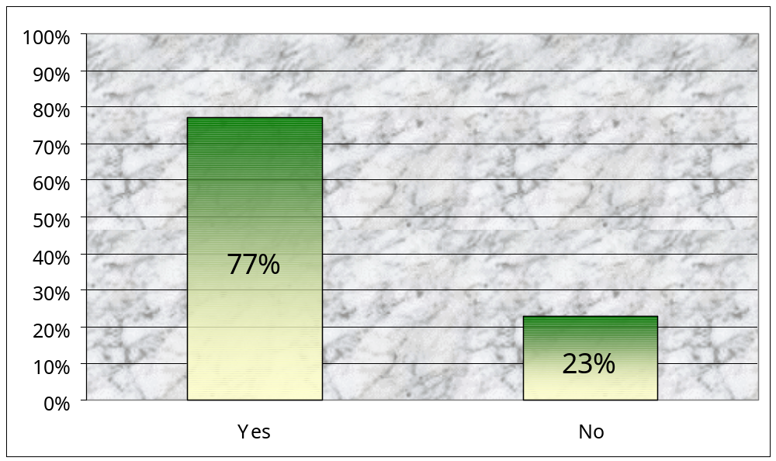
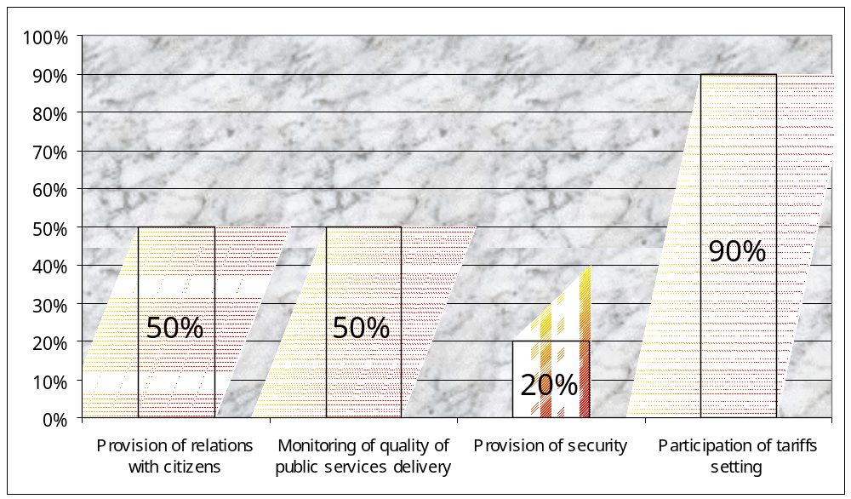
Results of the survey by questionnaire shows that the main part of responders consider necessary cooperation and participation of local governments in public utilities price setting, which are implemented by the Natural Monopolies Regulatory Commission. It will increase price setting justification and efficiency.

Chapter 4: Public Utilities Regulation in the European Countries
Study of public utilities in different countries show that water supply and central heating services, as a rule, are provided by local governments and electricity and gas services by the central government. But it is necessary to mention that percentage of mixed management and private sector is gradually increasing. In table 1. the note in the corresponding management form shows that the service is mainly delivered in that level.
Many organizational forms of public utilities delivering entities are known in all countries. Budgetary organizations, stock companies, limited-liability companies, etc. are among them. Owners of such organizations can be only local governments or different entities by different share. In Hungary, for example, in water supply sphere mainly local governments enterprises (44%) and budgetary organizations (38%) operate. In Latvia local governments enterprises percentage is 52% in this sphere.
There are different approaches related to the regulation, including price setting, of different spheres. For example, there are 3 models in electricity sphere:
- Centralized model. Central government body (Ministry of Economy in Slovakia) is responsible for the sphere regulation.
- Regulation by the State independent body. Large powers are given to this body (Romania, Poland).
- Decentralized model. Some powers are given to local governments (Latvia, Hungary).
The trend of public services delivery in these countries is privatization of the enterprises and increasing of the private sector role as well as market mechanisms usage in the public sector, encouragement of competition, contract relationship development, etc.
Table 1: Local Governments Responsibilities in the Field of Public Utilities
Country | Water Supply |  | Electricity |  |  | Gas |  |  | Central Heating
Country | Local Government | Central Government | Local Government | Central Government | Private or Mix Management | Local Government | Central Government | Private or Mix Management | Local Government | Central Government | Private or Mix Management
Estonia | * |  |  | * |  |  | * |  | *
Latvia | * |  | * | * |  |  | * |  | *
Lithuania | * |  |  | * |  |  | * |  | *
Poland | * |  | * |  |  | * |  |  | *
Czech | * |  | * |  |  | * |  |  | *
Slovakia | * | * |  | * |  |  | * |  | *
Hungary | * |  |  | * |  |  | * |  | *
Slovenia | * |  |  | * |  | * | * |  | *
Albania | * |  |  |  | * |  |  | * |  |  | *
Bulgaria | * | * |  | * |  |  | * |  | * | *
Croatia | * |  |  |  | * | * |  |  | *
Macedonia | * |  | * |  |  | * |  |  | *
Moldova | * |  | * |  |  | * |  |  | * | *
Romania | * |  |  | * |  |  | * |  | *

Conclusion
The issue of user charges and fees setting and regulation is a less developed in Armenian local self-government system. The latter itself has only seven years experience and there are many problems accumulated. Regulation of user charges and fees are among them.
- First off all legislation has to be improved. It is necessary to include all user charges and fees in the law on Local Duties and Fees. It will allow defining clearly the list of the fees, which should be defined by community elders. The law on Budgetary System has to define the cases when user charges and fees will be local budget revenue (e.g. when services are delivered by local governments). It is necessary to increase local governments powers in public services delivery matters and their participation in price setting (water supply, electricity, gas supply).
- All the major elements of a new model of local public service management should be put in place. The roles and functions of public clients, service producers (contractors), and consumers should be established and clearly separated.
- Regulatory institutions should be developed and endowed with clear-cut functions and autonomy from the government.
- Price regulation, methodologies should be developed for the calculation and design of tariffs including.
- Transitional arrangements during which subsidies or cross-subsidies between consumer groups should be phased out and metering should be phased-in.
- Hands on training on financial modeling for tariff-setting purposes would be provided.

It is necessary to have systematic and complex approaches to the local self-government system in general and local services delivery in particularly for implementation of above mentioned matters.

1 Deputy Chairman, Communities Finance Officers Association, Yerevan, Armenia.
In Western Europe and best practice emerging countries, collections are about 0.7-0.8 percent GDP.
According to GoA Decision No.55 24/01.2002 almost 247.000 customers in Yerevan are supposed to be serviced by the existing condominiums
Sources: Decentralization: Experiments and Reforms, edited by Tamas M. Horvath, Budapest, 2000; Stabilization of Local Government (2001). Edited by Emilia Kandeva. Budapest. OSI/LGI.

